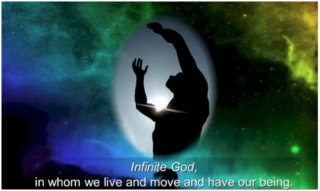
The Infinite and the Finite

Great I AM,
Fill my mind with elevation and grandeur at the thought of a Being
with whom one day is as a thousand years,
and a thousand years as one day;
A mighty God, who, amidst the decline of worlds,
and the revolutions of empires,
feels no variableness,
but is glorious in immortality.

May I rejoice that, while men die, Yahweh lives;
that, while all creations are fading flowers,
withering grass,
and vanishing mist,
You are the Rock of Ages, the everlasting Fountain of life.

My life is a gift of Your boundless being.
My time from Your timelessness.
I am in awe of a love that would take notice of me
while expanding universes and steering stars through their headings.
You have provided a way through Christ
for me to share in Your immortality.

Let me remember that earthly life is short
and is only an opportunity for usefulness.
Give me a holy greed to redeem the time,
to awake at every call to actions of love and opportunities for holy living,
so that I may feed the hungry,
clothe the naked,
instruct the unenlightened,
forgive the offender,
disperse the good news,
and show the grace of Christ to all.

Endless One,
turn my heart from fleeting idols,
from temporary satisfactions
to an eternal interest in a Savior who lives forever
and offers me an adoption into the family of the Infinite!

− The Valley of Vision, p. 104 with additions.

